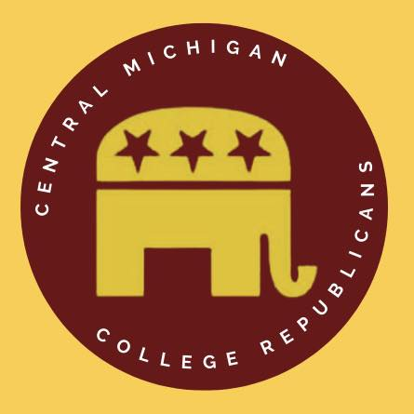
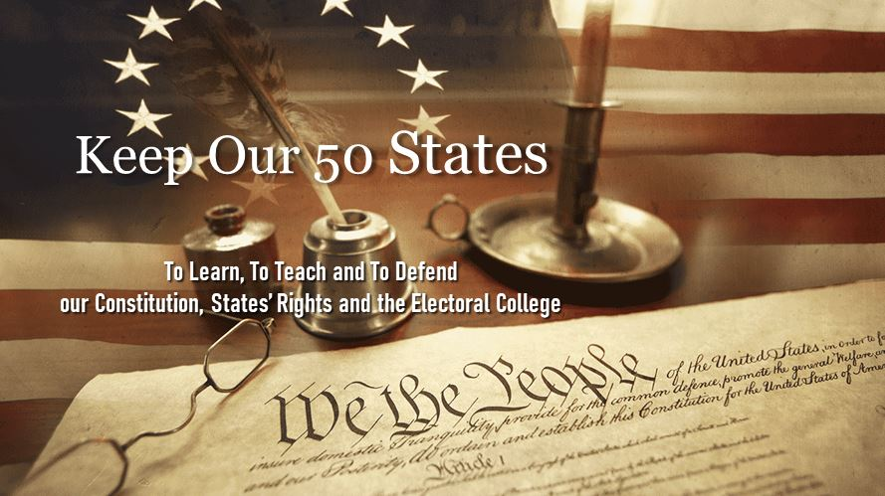
In Defense of Our
Electoral College
www.KeepOur50States.org
A presentation for
College Republicans at
Central Michigan University

April 2023 presentation by Tom Stillings and John Crawford, Volunteers, Keep Our 50 States
Also presenting as Volunteers: Rep. Ken Borton, R-10^{th,} Rep. John Roth, R-104th and Scott Greenlee, GOP Strategist

The ELECTORAL COLLEGE
- United STATES is still today “the Grand Experiment in Self-Governance”
  - Yet it is today the oldest continuous government in the world, among 195 nations.
  - James Madison explained in Federalist No. 51
    - “If men were angels, no government would be necessary. If angels were to govern men, neither external nor internal controls on government would be necessary. In framing a government which is to be administered by men over men, the great difficulty lies in this: you must first enable the government to control the governed; and in the next place oblige it to control itself.”
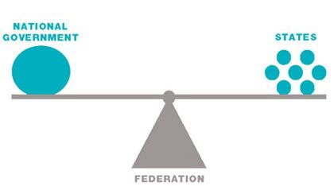
    - “The provision for defense (against a growing tyranny) must in this, as in all other cases, be made commensurate to the danger of attack. Ambition must be made to counteract ambition”.
    - They had to give the federal government enough power to control the governed, which are the States and the People, and simultaneously cause the governments to control themselves.
      - CHECKS and BALANCES
      - In addition to the 3 Branches
  - The Founders ALSO realized that democracies implode – most often suddenly and violently.
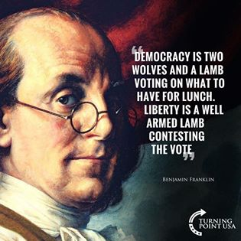
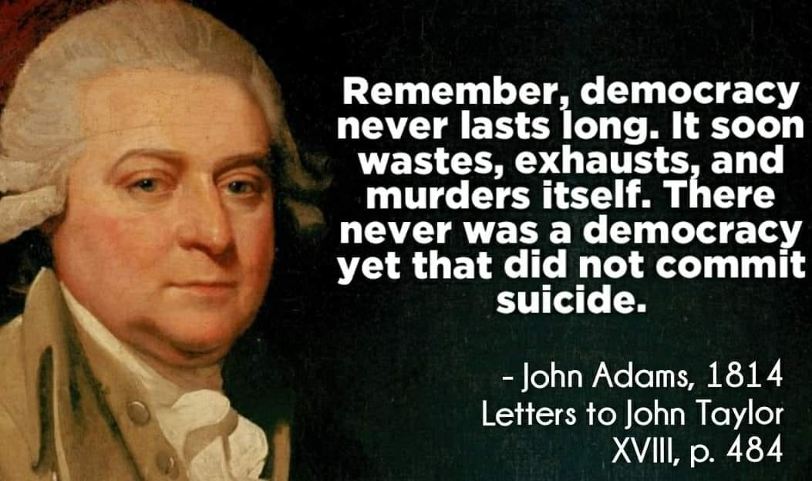

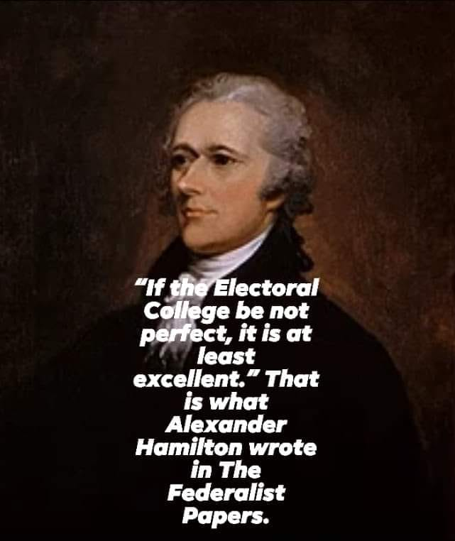
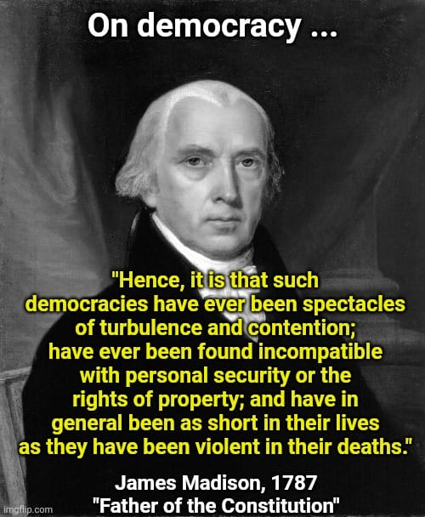
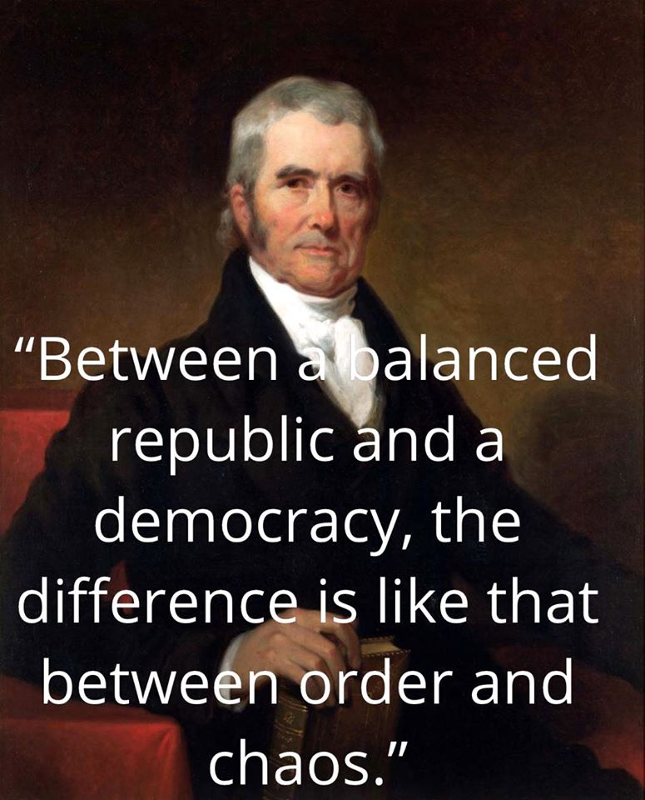
- The Founders were very much able to decide on and unanimously agreed to the Manner in which the President would be chosen
    - (Despite NPV past sales pitches statements to the contrary!)
    - They had proposed over a dozen different ways to choose the President
    - The proposed, debated and REJECTED popular voting at least 4 different times
  - On the last day of the 4-month Constitutional Convention in Philadelphia, James Madison and small committee
    - Alexander Hamilton explained in Federalist No. 68 in March 1788
      - “THE mode of appointment of the Chief Magistrate of the United States is almost the only part of the system, of any consequence, which has escaped without severe censure, or which has received the slightest mark of approbation from its opponents. The most plausible of these, who has appeared in print, has even deigned to admit that the election of the President is pretty well guarded.1 I venture somewhat further, and hesitate not to affirm, that if the manner of it be not perfect, it is at least excellent.”
  - ALL FIFTY (50) States have unanimously agreed to this method!
- The Electoral College is simply nothing more than the sovereign STATES casting their Votes to elect the President and Vice President of the United STATES. Very importantly, it is also nothing LESS.
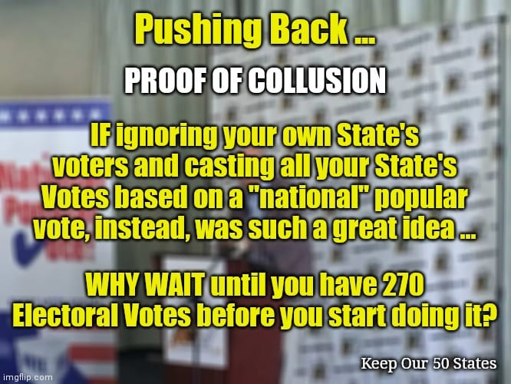
The National Popular Vote Interstate Compact Scheme
- IT IS NOT A NATIONAL LAW
- IT IS NOT A CONSTITUIONAL AMENDMENT
- IT IS A SIMPLE CONTRACT
  - They’re called “compacts” when governments enter them
- It is a Contract of Collusion
  - If it’s such a Good Idea to give away the control of your own State’s Votes, THEN WHY WAIT? Do it now!
  - By waiting until they have the 270-Vote majority, they COLLUDE to control all future elections as the Manner in which the Electors are chosen - to the detriment of other Legislatures wishing to exercise their Article 2 rights
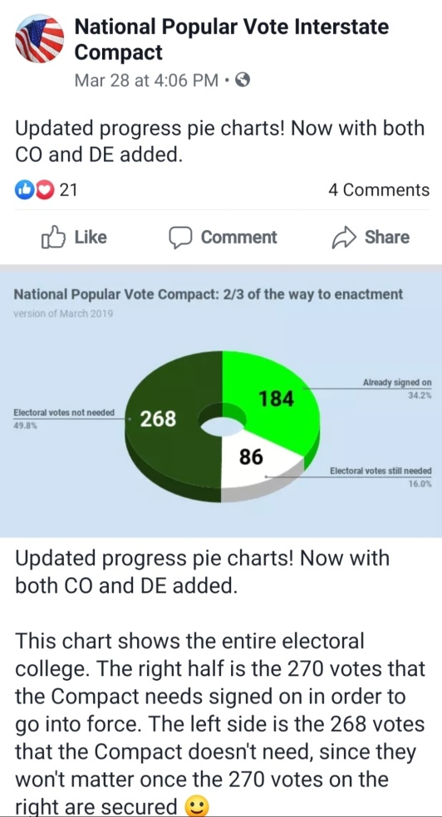
  - This post from March 2019 shows that NPV admits that once they control the majority of Votes, they do not need the rest of the States!
    - One NPV sales rep denied that their office produced this internal chart, but the fact of it still remains true! Had THEY not produced it, WE would have.
      - NPV admitting it or not is not relevant.
- The NPV Scheme DOES NOT “preserve” the EC!
  - It is in no position to preserve nor erase it!
  - It is actually HEMMED IN by the EC!
  - The EC is the Constitution. It needs no “preserving”.
  - IF it truly is “PRESERVING” the EC, then WHY does the Compact itself say at its Article 4, “This agreement shall terminate if the electoral college is abolished”?
- The NPV DOES NOT “overcome the shortcomings of Winner Take All laws”!
  - WTA Vote allocation has no shortcomings.
  - It is evidence that most States wish to vote AS STATES!
  - IF it was a problem, the NPV is NO solution!!
    - ANY State may change it’s Vote allocation laws at any time it wants to!
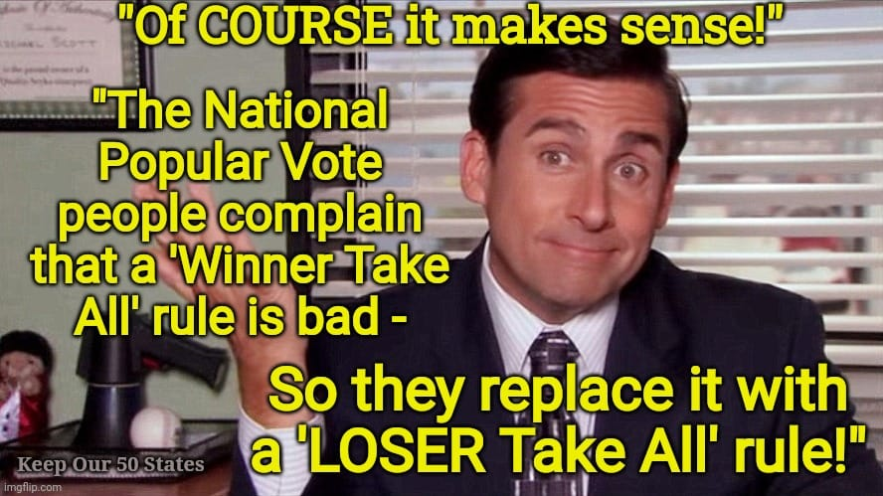
  - The dishonest NPV Scheme REPLACES each State’s WTA law with a LOSER TAKE ALL law!
- NPV Sales team claims that “Big Cities have only 5.8% of the population”!
  - They are disingenuous by COUNTING ONLY the Core City populations and ignoring the suburbs and surrounding Metropolitan Statistical Areas which tend to vote the same way.
  - Many of these areas straddle multi-State borders.
- NPV Sales people claim that “the one with the MOST votes wins” is the ultimate goal and achievement.
  - They say that The President is the ONLY office in the U.S. where that is not true! 10,000s are!
    - Completely FALSE!
The NPV compact replaces a Winner-Take-All law with a LOSER-Take-All law! They simply CHANGE who gets “disenfranchised”!
    - Democrat Party Nominees
    - League of Women Voters
    - Speaker of the Michigan House of Reps
    - CMU University President Robert Davies
  - Populations NEVER vote for the President! We vote for State ELECTORS! A HUGE difference.
  - The President of the United STATES has always been elected by – the STATES!
    - Proposals to have the US population elect the President were considered in great depth repeatedly and rejected. ALL States have ratified that unanimously. Article 2.
- NPV Sales folks claim that voters today “are DISENFRANCHISED”! (An ABSURD claim!)
  - They convince you that if you vote for a candidate who LOSES, you have been “disenfranchised”!
    - A totally irresponsible charge!
  - They say the NPV Contract of Collusion will assure that “no voter will ever be disenfranchised”!
    - Simply an absurd.
- The NPV Scheme makes voters dramatically UNEQUAL, not equal, as they claim!
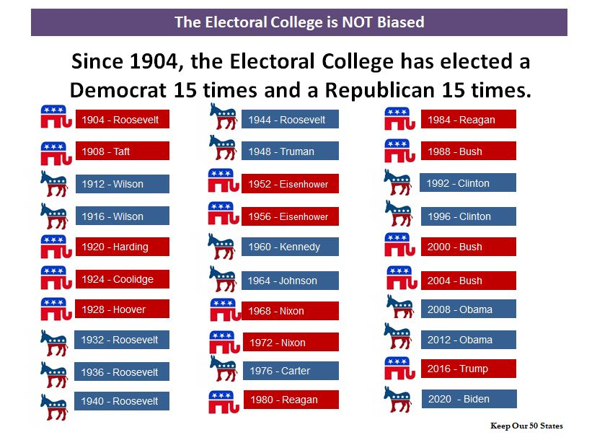
  - They intentionally conflate Campaign Rally Attendees, Campaign Mailer Recipients, Campaign Ad Watchers, et al, with VOTERS.
    - Actual VOTERS are very UNEQUAL under NPV
  - Remember the misdirection, “We PRESERVE the EC”?
    - That means that Michigan’s 15 Votes ARE STILL MICHIGAN’s 15 VOTES!
  - IT IS NOT A NATIONAL LAW
    - Only the 21 or 22 States who join their scheme will use their clever rules.
    - The majority of the STATES will not play along.
Apparently, the Electoral College is just not “Fair Enough”.
  - Compare Michigan voters with OHIO voters.
    - MICHIGAN voters influence on MICHIGAN’s Electors
      - MI makes up 3.5% of votes and therefore the decision.
        - Applies ONLY in MI and in the NPV States.
      - The rest of the decision (96.5%) belongs to NON-Michiganders!
        - 3.7% belongs to OHIO voters!
    - OHIO voters, are NOT in the NPV Scheme!
      - OH makes up 100.0% of the choice for OHIO’s 17 Votes!
      - MI voters have ZERO INFLUENCE over who OHIO Votes for!
  - HOW CAN ANYONE THINK THAT “VOTERS ARE MADE EQUAL” under the NPV?!
- WHAT IF? Just a handful of “WHAT IFs” under the NPV Scheme–
  - California LOWERS their voting age to age 16?
    - NON-Californian 16 & 17 year olds are “disenfranchised”! See any problem?
  - Drought out West. Leading Candidate promises to pipe the Great Lakes out to the arid West.
    - California alone at 54 Votes has more Votes than MI, and ALL of MI Votes could go to the candidate promising to pump the Great Lakes to the West Coast!
  - MI are enraged after November election, MI lawmakers feel their wrath and on Nov 20th, the Legislature decides to IGNORE the NPV Compact commitment.
    - WHO could sue? What a MESS!
- ORIGINAL developer of the NPV concept, U of Illinois Law School Dean and professor Vikram Amar has himself distanced himself from the NPC Scheme because of its defects, although he still wants the STATES removed from electing the President.
Other Resources
- www.KeepOur50States.Org/Resources and various State Pages
- www.SaveOurStates.Com
- www.safeguard.film
Keep Our 50 States - Help us to defend the Electoral College!
Contact us at
Keep Our 50 States.Org

20230305
20230407

